Q1)

#include <iostream>

namespace std;

int calculateSum(int a, int b) {

return a + b;

}

int main() {

int num1, num2;

cout << "Enter the first number: ";

cin >> num1;

cout << "Enter the second number: ";

cin >> num2;

int sum = calculateSum(num1, num2);

cout << "The sum is: " << sum << endl;

return 0;

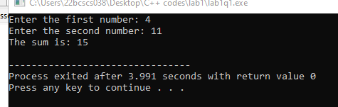

Q2)

#include <iostream>

using namespace std;

int findMaximum(int a, int b, int c) {

int maxNum = a;

if (b > maxNum)

maxNum = b;

if (c > maxNum)

maxNum = c;

return maxNum;

}

int findMinimum(int a, int b, int c) {

int minNum = a;

if (b < minNum)

minNum = b;

if (c < minNum)

minNum = c;

return minNum;

}

int main() {

int num1, num2, num3;

cout << "Enter the first number: ";

cin >> num1;

cout << "Enter the second number: ";

cin >> num2;

cout << "Enter the third number: ";

cin >> num3;

int maximum = findMaximum(num1, num2, num3);

int minimum = findMinimum(num1, num2, num3);

cout << "Maximum number: " << maximum << endl;

cout << "Minimum number: " << minimum << endl;

return 0;

}

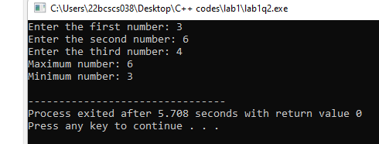

Q3)

#include <iostream>

using namespace std;

void displayGrade(int marks) {

if (marks >= 91 && marks <= 100) {

cout << "Grade: AA" << endl;

} else if (marks >= 81 && marks <= 90) {

cout << "Grade: AB" << endl;

} else if (marks >= 71 && marks <= 80) {

cout << "Grade: BB" << endl;

} else if (marks >= 61 && marks <= 70) {

cout << "Grade: BC" << endl;

} else if (marks >= 51 && marks <= 60) {

cout << "Grade: CD" << endl;

} else if (marks >= 41 && marks <= 50) {

cout << "Grade: DD" << endl;

} else if (marks <= 40) {

cout << "Grade: Fail" << endl;

} else {

cout << "Invalid marks entered!" << endl;

}

}

int main() {

int marks;

cout << "Enter your marks (out of 100): ";

cin >> marks;

displayGrade(marks);

return 0;

}

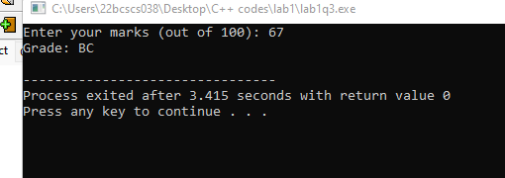

Q4)

#include <iostream>

#include <string>

using namespace std;

struct Student {

int rollNo;

string name;

int age;

float marks;

};

void printStudentDetails(Student student) {

cout << "Roll No.: " << student.rollNo << endl;

cout << "Name: " << student.name << endl;

cout << "Age: " << student.age << endl;

cout << "Marks: " << student.marks << endl;

}

int main() {

Student student;

cout << "Enter Roll No.: ";

cin >> student.rollNo;

cin.ignore();

cout << "Enter Name: ";

getline(cin, student.name);

cout << "Enter Age: ";

cin >> student.age;

cout << "Enter Marks: ";

cin >> student.marks;

cout << "\nStudent Details:\n";

printStudentDetails(student);

return 0;

}

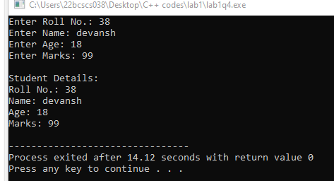

Q5)

#include <iostream>

#include <string>

using namespace std;

struct Marks {

int rollNo;

string name;

float chemMarks;

float mathsMarks;

float phyMarks;

float percentage; // Added member variable

};

void calculatePercentage(Marks& student) {

float totalMarks = student.chemMarks + student.mathsMarks + student.phyMarks;

float percentage = (totalMarks / 300) \* 100;

student.percentage = percentage;

}

void displayStudentDetails(Marks student) {

cout << "Roll No.: " << student.rollNo << endl;

cout << "Name: " << student.name << endl;

cout << "Chemistry Marks: " << student.chemMarks << endl;

cout << "Mathematics Marks: " << student.mathsMarks << endl;

cout << "Physics Marks: " << student.phyMarks << endl;

cout << "Percentage: " << student.percentage << "%" << endl;

cout << endl;

}

int main() {

Marks students[5];

for (int i = 0; i < 5; i++) {

cout << "Enter details for student " << i + 1 << ":" << endl;

cout << "Roll No.: ";

cin >> students[i].rollNo;

cin.ignore();

cout << "Name: ";

getline(cin, students[i].name);

cout << "Chemistry Marks: ";

cin >> students[i].chemMarks;

cout << "Mathematics Marks: ";

cin >> students[i].mathsMarks;

cout << "Physics Marks: ";

cin >> students[i].phyMarks;

calculatePercentage(students[i]);

cout << endl;

}

cout << "Student Details:\n";

for (int i = 0; i < 5; i++) {

displayStudentDetails(students[i]);

}

return 0;

}

